**Fundraising Event** benefiting

*River Valley Nursing Center*

**Sip, Swirl, and Socialize**

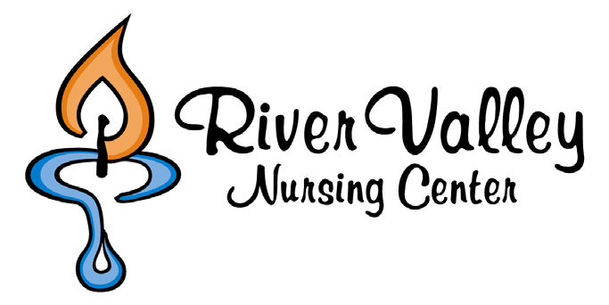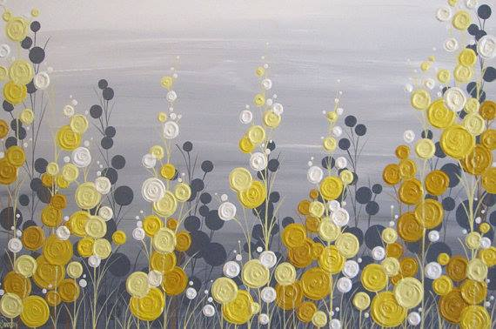

**This is the picture we will be painting.**

**Everyone is an artist at this event!**

[Click Here To Register](http://rivervalleynursingcenter.org/get-involved-2/)

*Questions –rivervalleync@aol.com*

***Ticket price is $50, which includes all painting supplies and instruction by local artist***

***(Eat Drink Paint Montgomery)***

$30 from your ticket will benefit the River Valley Nursing Center.

Food and beverage available for purchase.

**Thursday, November 5th**

***Dangerfield’s Restaurant (lower level)***

***1583 East First Ave ~ Shakopee, MN***

**5:00pm-6:15pm – Happy Hour – beverages & food available for purchase**

**6:15pm – PAINTING BEGINS**